Clinigence REAL WORLD TESTING RESULTS REPORT 2025
Under the ONC Health IT Certification Program (Certification Program), health IT developers are required to conduct Real World Testing of their certified health IT (45 CFR 170.405). The Office of the National Coordinator for Health Information Technology (ONC) issues Real World Testing resources to clarify health IT developers’ responsibilities for conducting Real World Testing, to identify topics and specific elements of Real World Testing that ONC considers a priority, and to assist health IT developers in developing their Real World Testing plans and results reports.
Changes to Original Plan 2
Summary of Testing Methods and Key Findings 3
Standards Updates (Including Standards Version Advancement Process (SVAP) and United States Core Data for Interoperability (USCDI)) 3
Metrics and Outcomes 4
Associated Certification criteria 4
Description of measurement/metrics 6
Care Settings 6
Expected outcomes 6
Measure 1: Data Extraction and Import. 7
Measure 2: Calculate and Validate 11
Initial Implementation 11
Validation Process 13
Variance Checks 15
Quality Data validation Audit 15
Measure 3: Submitting Reports to CMS 19
Example – Manhattan, KS Organization 20
Measure 4: Single Patient ExporT 22
Measure 5: Patient Population Export 22
Key Milestones 23
Attestation 24

General Information
Plan Report ID Number: [For ONC-Authorized Certification Body use only]
Developer Name: Clinigence Health
Product Name(s): Clinigence Value Improvement Platform (VIP)
Version Number(s): 4.5
Certified Health IT Product List (CHPL) ID(s): 15.04.04.2696.Clin.05.00.0.181231
Developer Real World Testing Page URL: http://clinigencehealth.com/cures-act-real-world-testing/

Changes to Original Plan
Changes to the approach for Real World Testing that differ from what was outlined in the plan, are noted here.

Summary of Change | Reason | Impact
No changes needed

Summary of Testing Methods and Key Findings
Summary of the Real World Testing methods deployed to demonstrate real-world interoperability, including any challenges or lessons learned from the chosen approach. Summarize how the results that will be shared in this report demonstrate real-world interoperability.

Standards Updates (Including Standards Version Advancement Process (SVAP)
and United States Core Data for Interoperability (USCDI))
Both required and voluntary standards updates must be addressed in the Real World Testing plan. Real World Testing plans must include all certified health IT updated to newer versions of standards prior to August 31 of the year in which the updates were made.

Indicate as to whether optional standards, via SVAP and/or USCDI, are leveraged as part of the certification of your health IT product(s).
- Yes, I have products certified with voluntary SVAP or USCDI standards. (If yes, please complete the table below.
- No, none of my products include these voluntary standards.
Standard (and version) | The standards for §170.315(c)(3) Clinical Quality Measures (CQMs) – Report (Cures) were followed when we generated the QRDA CAT III reports that we uploaded to the QPP portal for MIPS reporting.
Updated certification criteria and associated product
CHPL Product Number | 15.04.04.2696.Clin.05.00.0.181231
Method used for standard update
Date of ONC ACB notification
Date of customer notification (SVAP only)
USCDI updated certification criteria (and USCDI version)

Metrics and Outcomes
Outcomes from the testing that successfully demonstrate that the certified health IT:

- is compliant with the certification criteria, including the required technical standards and vocabulary codes sets;
- is exchanging electronic health information (EHI) in the care and practice settings for which it is marketed for use; and/or,
- EHI is received by and used in the certified health IT.

from 85 FR 25766)

Associated Certification criteria
List certification criteria associated with the measure and if updated to 2015 Edition Cures Update criteria.
Certification Criteria | Requirement
§170.315(c)(3) Clinical Quality Measures (CQMs) – Report (Cures) | (c )(3)Generate an aggregate report with calculated summary data for the patient population of the clinical quality measures calculated in the Execute test (§ 170.315(c)(2)), which at a minimum is in accordance with the standard specified in § 170.205(k)(3). CMS Implementation Guide for Quality Reporting Document Architecture: Category III; Eligible Clinicians and Eligible Professionals Programs; Implementation Guide for 2020  Generate a de-duplicated archive of patient documents in the CMS QRDA Category I IG format of the clinical quality measures calculated in the Execute test (§ 170.315(c)(2)), which at a minimum is in accordance with the standard specified in § 170.205(h)(3). CMS Implementation Guide for Quality Reporting Document Architecture: Category I; Hospital Quality Reporting; Implementation Guide for 2020  Submit the quality measurement data file consisting of the data created by the generation of the CMS QRDA Category III IG aggregate report(s) and the de-duplicated CMS QRDA Category I IG report(s) for verification.

§ 170.315(b)(10) EHI export – Patient population EHI export | Single patient EHI export:  (i)(A) Create an export file  (i)(B) Execute at any time  (i)(C) Limit ability of users who can create export  (i)(D) Electronic and computable format  Patient population EHI export:  (ii)(A) Create an export file

Description of measurement/metrics
The following outlines the five measures that were identified to best demonstrate conformance to multiple certification criteria concerning Clinical Quality Measures (170.315 (c)(1): Record and Export, 170.315 (c)(2): Import and Calculate, and 170.315 (c)(3): Report across the use cases demonstrated and § 170.315(b)(10)) across the two use cases demonstrated (single patient and population services).
Measure 1: Data Extraction and Import.
Measure 2: Calculate and Validate. Clinigence will use the following audit processes for the quality data submission:
• Initial Implementation
• Variance Checks (planned)
• Quality Data Validation Audit Prior to Submission

Measure 3: Submitting Reports to CMS.

Measure 4: Single Patient Export

Measure 5: Patient Population Export

Care Settings
Each care setting that was tested is listed below.

Care Setting | Justification
Group | Clinigence generated and submitted one file for all NPIs in The TIN (group). Scores were aggregated in the CAT III file for the entire group.
Individual | Clinigence generated and submitted one file for each provider. This can be for a single provider practice or multiple providers under the same TIN. One CAT III file was generated per NPI.

Expected outcomes
It was expected that authorized users would be able to generate measure scores for each EP and generate the files needed to upload to the QPP portal for the yearly MIPS submission. Any errors found were tracked, analyzed, and corrected so that 100% of the MIPS submissions were accepted by CMS. These expectations were fully realized.

Measure 1: Data Extraction and Import.
This measure demonstrates the ability to use our proprietary data extraction tools to consume data from various sources and formats and import that data into our database.
Quality data via QRDA CAT III were submitted for a total of 15 TINs for PY2024 (MIPS and programs). We’ve removed the TINs and organization names for privacy.
Description | Clinigence ID | Quality Data Submission Status | QPP Submission ID | Program Reported | Method to Consume Data | Number of Data Files Extracted/Loaded
Cuyahoga Falls, OH | 31471798 | Completed | *0f757e05-b9c0-4fb2-af69-2a463a71c7d1  *0f757e05-7a5d-40a3-8788-3bca48716025  *0f757e05-fca2-436c-bb57-7b200ca6838e | MIPS 2024  Submitted as Qualified Registry for 3 providers | Cuyahoga Falls hosts the EMR. Clinigence extracts data directly from the EMR nightly. | From 1/1/2024 through 12/31/2024:  Total: 951,708 files
Bowling Green, KY | 348543718 | Completed | 0f45252d-652d-45c4-a0e0-4f80c12d7a8e | MIPS 2024  Submitted as Qualified Registry for 1 Individual provider | Bowling Green pushed EMR data weekly. | From 1/1/2024 through 03/01/2025:  Total: 215 files
Bismarck, ND | 347912218 | Completed | 0f69a6d7-6c49-4350-b0db-e36e0edf9754 | MIPS 2024  Submitted as Qualified Registry for 1 Group of 4 Providers | Bismarck pushed EMR data weekly. | From 1/1/2024 through 03/01/2025:  Total: 375 files
Lawton, OK | 347744196 | Completed | 0f6962ac-ad59-4a65-934c-463fd7a1912d | MIPS 2024  Submitted as Qualified Registry for 1 Group of 12 Providers | Lawton pushed EMR data weekly. | From 1/1/2024 through 03/01/2025:  Total: 375 files
Manhattan, KS | 348309302 | Completed | 0f2bbc5d-77f1-41f7-95cb-58740d34f979 | MIPS 2024  Submitted as Qualified Registry for 1 Individual provider | Manhattan pushed EMR data weekly. | From 1/1/2024 through 03/01/2025:  Total: 150 files
Roseburg, OR | 347720174 | Completed | 0f59f16d-b827-4519-90f0-96837c20c61c | MIPS 2024  Submitted as Qualified Registry for 1 Group of 3 Providers | Roseburg pushed EMR data weekly. | From 1/1/2024 through 03/01/2025:  Total: 345 files
Broomall, PA | 347750136 | Completed | *0f6b0a16-14ba-4cd1-bd8c-6c49f1936e25  * 0f76cfe3-ddcc-4d30-8f72-2a9a7c2fc441  * 0f76d891-d384-4ee5-b3a0-7a21fa882ac4  * 0f76db60-3c6f-4a75-b373-5870a178016d  * 0f77e191-3bdc-46d9-8839-6b48331ea9b7  * 0f77e544-ae1a-4e63-b1a7-750063dda409  * 0f77e838-d9d5-4ac7-b641-59fe7cb3e953 | MIPS 2024  Submitted as Qualified Registry for 1 Group of 6 Providers (submitted twice - 1 MVP and 1 Traditional MIPS); 6 Individual Providers as Traditional MIPS | Broomhall pushed EMR data weekly. | From 1/1/2024 through 03/01/2025:  Total: 420 files
Peoria, IL | 347664221 | Completed | 0f67f44d-641b-44fb-9ae2-cf21ad3ac218 | MIPS 2024  Submitted as Qualified Registry for 1 Group of 60 Providers (MVP) | Peoria pushed EMR data weekly. | From 1/1/2024 through 03/01/2025:  Total: 299 files
Edina, MN | 347752845 | Completed | 0f34aa02-bb43-45f9-ba8a-80c402f0c12e | MIPS 2024  Submitted as Qualified Registry for 1 Individual provider | Edina pushed EMR data weekly. | From 1/1/2024 through 03/01/2025:  Total: 1,219 files
Dunmore, PA | 347860364 | Completed | *0f6c4349-0963-4316-90ad-623e8f921e01  *0f6c43ab-55e8-4cae-bd9a-651806bf4e3d  * 0f6c43c4-e83f-4163-adf0-f7a702e68d5f  *0f6c43e2-40f8-4ebe-b898-3ab26e84b792 | MIPS 2024  Submitted as Qualified Registry for 1 Group of 4 Providers | Dunmore pushed EMR data weekly. | From 1/1/2024 through 03/01/2025:  Total: 375 files
Providence, RI | 350172151 | Completed | 0f503a3d-e581-4110-9141-5f45d96cd27e | MIPS 2024  Submitted as Qualified Registry for 1 Group of 4 Providers | Providence pushed EMR data weekly. | From 1/1/2024 through 03/01/2025:  Total: 105 files

Somerset, NJ | 347752842 | Completed | *0f6800a4-5e46-46b6-9e31-3ef290f5c16  *0f67fe92-3f55-4b5c-9f4e-02e57d061344  *0f6802e4-5ccb-413e-854b-71a6fc9ddd5c  *0f6801a5-777a-4b7b-afe1-d918f0094230 | MIPS 2024  Submitted as Qualified Registry for 4 Individual providers | Somerset pushed EMR data weekly. | From 1/1/2024 through 03/01/2025:  Total: 449 files
Huntington, WV | 347753281 | Completed | 0f5de7fa-855f-4b53-baf8-9107606f7872 | MIPS 2024  Submitted as Qualified Registry for 1 Individual provider | Huntingdon pushed EMR data weekly. | From 1/1/2024 through 03/01/2025:  Total: 446 files
Las Vegas, NV | 26817862 | Completed | 0f0e673d-17fd-47cf-b431-5cff699bbf62 | MIPS 2024 submitted as Qualified Registry, APP Reporting Option | Las Vegas pushed EMR data periodically. | From 1/1/2024 through 3/1/2025:  Total: 3,251,560 files
Tacoma, WA | 4799211 | Completed | 0f0e6673-5da0-4488-9bae-f8367070cb23 | MIPS 2024 submitted as Qualified Registry, APP Reporting Option | Tacoma pushed EMR data periodically | From 1/1/2024 through 3/1/2025:  Total: 127,480 files

Measure 2: Calculate and Validate
This measure demonstrated the ability to use the imported PHI to calculate specific MIPS eCQM and CQM measures for the PY 2024 according to that year’s measure specifications. Clinigence used the following audit Processes for the Quality data submission:
- Initial Implementation – accuracy of numerator, denominator and exclusion criteria results are verified by working with the practice after an EP’s data is initially loaded, mapped, and calculated.
- Variance Checks - Periodic manual checking for unusual variances in report results and, if found, notified Clinigence support and development teams.
- Quality Data Validation Audit Prior to Submission – At least 3% of the TIN/NPIs submitted to CMS (with a minimum of 10 or maximum of 50 TIN/NPIs), with at least 25% of the TIN/NPI's patients (with a minimum 5 patients or maximum sample of 50 patients) for a specific quality measure implemented for 2023. The audit is performed as soon as all data has been loaded and processed for all the 2023 quality measures for each TIN/NPI implemented for 2023 submission. (i.e., Results of the random audits/targeted audits, identifying calculation issues, why they occurred and what was done to remediate.)

Initial Implementation
The Clinigence Health application implements each program via a Performance Dashboard that the customers can review and use to assist in validating the accuracy of the scores. Two views of the Performance Dashboard for Cuyahoga Falls are shown below (columns with PHI are obscured)
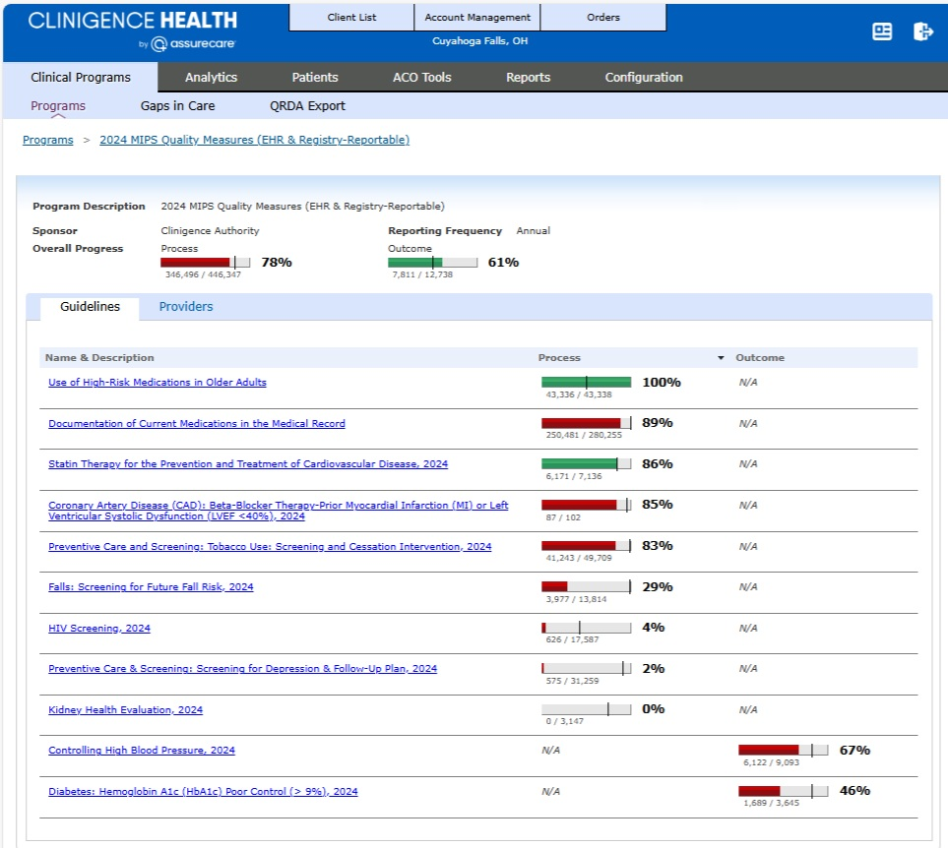
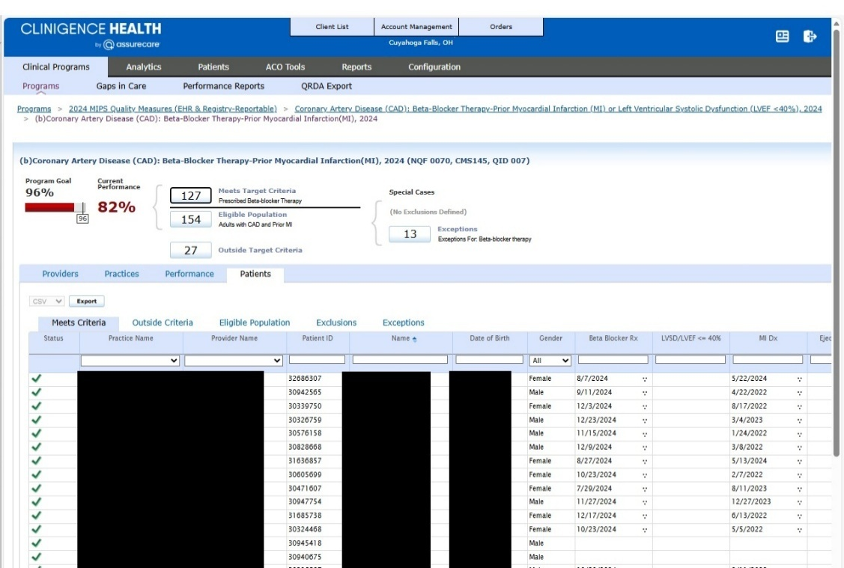

Validation Process
Random audit worksheets were generated for the measures selected for reporting. A support ticket was created for each organization with boilerplate instructions:
Customer,
I am attaching the random patient audit for your 2024 MIPS measures.
The purpose of the validation worksheet is to ensure that the numbers for reporting are as accurate as possible. The attached worksheet lists the audited patients and their status for each measure (Not Eligible, Numerator, Complement, Exclusion). We need you to confirm that the patients are classified correctly. Please use this ticket when noting any specific example patient data.
Not Eligible - Patient does not meet the denominator requirements for the measure
Numerator - Patient meets the numerator requirements for the measure. The report includes the date the patient qualified if they are in the numerator.
Complement - Patient is eligible for the measure but does not meet the numerator requirements
Exclusion/Exception - Patient is excluded (limited life expectancy, in hospice, refused if applicable, etc)
You can edit the attached document and add any notes. For example, change to green if validated in the EMR or red if incorrect. If incorrect, please provide as much detail as possible or note that there is no documentation in the EMR to support the Clinigence classification. We'll investigate any issues found and perform a detailed audit once resolved.
Please respond with your findings so we can investigate and address any issues.
Thanks,

Attached to the support ticket was the random audit worksheet, an example (de-identified) shown here:
Clinigence ID | Patient Name | Gender | DateOfBirth | Age | Documentation of Current  Medications in the Medical Record | Documentation of Current Medications in the  Medical Record Qualify Date | Episode Key | Episode Date
30502682 | AD | F | MM/DD/1957 | 66 | Numerator | 8/3/2024 | 577150507 | 8/3/2024
30502682 | AD | F | MM/DD/1957 | 66 | Numerator | 03/19/2024 | 577150513 | 03/19/2024
30502682 | AD | F | MM/DD/1957 | 66 | Numerator | 03/19/2024 | 577150538 | 03/19/2024
30502682 | AD | F | MM/DD/1957 | 66 | Numerator | 3/6/2024 | 591887945 | 3/6/2024
30502682 | AD | F | MM/DD/1957 | 66 | Numerator | 3/6/2024 | 591887981 | 3/6/2024
30502682 | AD | F | MM/DD/1957 | 66 | Numerator | 3/6/2024 | 592714689 | 3/6/2024
30502682 | AD | F | MM/DD/1957 | 66 | Numerator | 3/6/2024 | 592714690 | 3/6/2024
30502682 | AD | F | MM/DD/1957 | 66 | Numerator | 3/6/2024 | 592714700 | 3/6/2024
30502682 | AD | F | MM/DD/1957 | 66 | Complement |  | 592714701 | 12/6/2024
30502682 | AD | F | MM/DD/1957 | 66 | Complement |  | 592714702 | 12/6/2024
31495289 | AC | M | MM/DD/1991 | 33 | Numerator | 02/22/2024 | 580899677 | 02/22/2024
31495289 | AC | M | MM/DD/1991 | 33 | Numerator | 02/22/2024 | 580899689 | 02/22/2024
31495289 | AC | M | MM/DD/1991 | 33 | Numerator | 11/6/2024 | 592571213 | 11/6/2024
31495289 | AC | M | MM/DD/1991 | 33 | Numerator | 11/6/2024 | 592571233 | 11/6/2024
30828193 | YSJ | M | MM/DD/1971 | 53 | Complement |  | 565988351 | 4/1/2024
30828193 | YSJ | M | MM/DD/1971 | 53 | Complement |  | 565988357 | 4/1/2024
30828193 | YSJ | M | MM/DD/1971 | 53 | Complement |  | 565988363 | 4/1/2024
30373043 | ZE | F | MM/DD/1935 | 88 | Numerator | 3/1/2024 | 566124101 | 3/1/2024
30373043 | ZE | F | MM/DD/1935 | 88 | Numerator | 03/22/2024 | 581781317 | 03/22/2024
30373043 | ZE | F | MM/DD/1935 | 88 | Numerator | 10/5/2024 | 595258974 | 10/5/2024
30373043 | ZE | F | MM/DD/1935 | 88 | Numerator | 06/21/2024 | 595599707 | 06/21/2024
30828560 | ZJ | M | MM/DD/1968 | 56 | Numerator | 6/3/2024 | 577679224 | 6/3/2024
30828560 | ZJ | M | MM/DD/1968 | 56 | Numerator | 6/3/2024 | 577679229 | 6/3/2024
30828560 | ZJ | M | MM/DD/1968 | 56 | Numerator | 6/3/2024 | 577679257 | 6/3/2024
30828560 | ZJ | M | MM/DD/1968 | 56 | Numerator | 05/22/2024 | 589943302 | 05/22/2024

Feedback with customer was handled in the support ticketing system to protect PHI.

Variance Checks
Periodic manual checks were performed to ensure that the measure scores did not show extreme changes from day to day while we were processing the data.

Quality Data validation Audit
The following table shows the details for the data validation and group submissions for 15 TINs:
Clinigence ID | Description | Patient Audit Status | # Measures | Quality Data Submission Status | QPP Submission ID
10952196 | Cuyahoga Falls, OH | Random audit attached to support ticket 12111. | 11 | Complete | *0f757e05-b9c0-4fb2-af69-2a463a71c7d1  *0f757e05-7a5d-40a3-8788-3bca48716025  *0f757e05-fca2-436c-bb57-7b200ca6838e
348543718 | Bowling Green, KY | Random audit attached to support ticket 12800. | 8 | Complete | 0f45252d-652d-45c4-a0e0-4f80c12d7a8e
347912218 | Bismarck, ND | Random audit attached to support ticket 12553. | 6 | Complete | 0f69a6d7-6c49-4350-b0db-e36e0edf9754
347744196 | Lawton, OK | Random audit attached to support ticket 12623. | 8 | Complete | 0f6962ac-ad59-4a65-934c-463fd7a1912d
348309302 | Manhattan, KS | Random audit attached to support ticket 12670. | 7 | Complete | 0f2bbc5d-77f1-41f7-95cb-58740d34f979
347720174 | Roseburg, OR | Random audit attached to support ticket 12649. | 7 | Complete | 0f59f16d-b827-4519-90f0-96837c20c61c
347750136 | Broomall, PA | Random audit attached to support ticket 12550. | 10 | Complete | *0f6b0a16-14ba-4cd1-bd8c-6c49f1936e25  *0f76cfe3-ddcc-4d30-8f72-2a9a7c2fc441  *0f76d891-d384-4ee5-b3a0-7a21fa882ac4  *0f76db60-3c6f-4a75-b373-5870a178016d  *0f77e191-3bdc-46d9-8839-6b48331ea9b7  *0f77e544-ae1a-4e63-b1a7-750063dda409  *0f77e838-d9d5-4ac7-b641-59fe7cb3e953
347664221 | Peoria, IL | Random audit attached to support ticket 12675. | 7 | Complete | 0f67f44d-641b-44fb-9ae2-cf21ad3ac218
347752845 | Edina, MN | Random audit attached to support ticket 12650. | 7 | Complete | 0f34aa02-bb43-45f9-ba8a-80c402f0c12e
347860364 | Dunmore, PA | Random audit attached to support ticket 12651. | 6 | Complete | *0f6c4349-0963-4316-90ad-623e8f921e01  *0f6c43ab-55e8-4cae-bd9a-651806bf4e3d  *0f6c43c4-e83f-4163-adf0-f7a702e68d5f  *0f6c43e2-40f8-4ebe-b898-3ab26e84b792
350172151 | Providence, RI | Random audit attached to support ticket 12892. | 6 | Complete | 0f503a3d-e581-4110-9141-5f45d96cd27e
347752842 | Somerset, NJ | Random audit attached to support ticket 12608. | 7 | Complete | *0f6800a4-5e46-46b6-9e31-3ef290f5c16  *0f6800a4-5e46-46b6-9e31-3ef290f5c16  *0f6802e4-5ccb-413e-854b-71a6fc9ddd5c  *0f6801a5-777a-4b7b-afe1-d918f0094230
347753281 | Huntington, WV | Random audit attached to support ticket 12607. | 6 | Complete | 0f5de7fa-855f-4b53-baf8-9107606f7872
26817862 | Las Vegas, NV | Random audit attached to multiple support tickets by practice: 12294, 12190, 12241, 12248, 12341, 12249, 12403, 12475, 12550, 12551, 12344, 12446, 12273, 12348, 12338, 12445, 12321, 12340, 12343, 12342, 12198, 12317, 12368, 12375, 12376, 12386, 12199, 12390, 12517, 12639, 12391, 12392, 12394, 12320, 12518, 12444, 12319, 12395, 12397, 12272, 12398, 12293, 12200, 12399, 12300, 12289, 12400, 12401, 12402, 12318. | 3 | Complete | 0f0e673d-17fd-47cf-b431-5cff699bbf62
4799211 | Tacoma, WA | Random audit attached to support ticket 30177. | 3 | Complete | 0f0e6673-5da0-4488-9bae-f8367070cb23

Measure 3: Submitting Reports to CMS
This measure demonstrated the ability to submit MIPS scores to CMS. We generated the required QRDA Cat III files, uploaded to CMS via the QPP portal, and downloaded the scores and submission ID.
Description | QPP Submission ID
Cuyahoga Falls, OH | *0f757e05-b9c0-4fb2-af69-2a463a71c7d1  *0f757e05-7a5d-40a3-8788-3bca48716025  *0f757e05-fca2-436c-bb57-7b200ca6838e
Bowling Green, KY | 0f45252d-652d-45c4-a0e0-4f80c12d7a8e
Bismarck, ND | 0f69a6d7-6c49-4350-b0db-e36e0edf9754
Lawton, OK | 0f6962ac-ad59-4a65-934c-463fd7a1912d
Manhattan, KS | 0f2bbc5d-77f1-41f7-95cb-58740d34f979
Roseburg, OR | 0f59f16d-b827-4519-90f0-96837c20c61c
Broomall, PA | *0f6b0a16-14ba-4cd1-bd8c-6c49f1936e25  *0f76cfe3-ddcc-4d30-8f72-2a9a7c2fc441  *0f76d891-d384-4ee5-b3a0-7a21fa882ac4  *0f76db60-3c6f-4a75-b373-5870a178016d  *0f77e191-3bdc-46d9-8839-6b48331ea9b7  *0f77e544-ae1a-4e63-b1a7-750063dda409  *0f77e838-d9d5-4ac7-b641-59fe7cb3e953
Peoria, IL | 0f67f44d-641b-44fb-9ae2-cf21ad3ac218
Edina, MN | 0f34aa02-bb43-45f9-ba8a-80c402f0c12e
Dunmore, PA | *0f6c4349-0963-4316-90ad-623e8f921e01  *0f6c43ab-55e8-4cae-bd9a-651806bf4e3d  *0f6c43c4-e83f-4163-adf0-f7a702e68d5f  *0f6c43e2-40f8-4ebe-b898-3ab26e84b792
Providence, RI | 0f503a3d-e581-4110-9141-5f45d96cd27e
Somerset, NJ | *0f6800a4-5e46-46b6-9e31-3ef290f5c16  *0f6800a4-5e46-46b6-9e31-3ef290f5c16  *0f6802e4-5ccb-413e-854b-71a6fc9ddd5c  *0f6801a5-777a-4b7b-afe1-d918f0094230
Huntington, WV | 0f5de7fa-855f-4b53-baf8-9107606f7872
Las Vegas, NV | 0f0e673d-17fd-47cf-b431-5cff699bbf62
Tacoma, WA | 0f0e6673-5da0-4488-9bae-f8367070cb23

Example – Manhattan, KS Organization
We chose the organization in Manhattan, KS, to demonstrate the submission measure.
Manhattan, KS Submission Details
Clinigence ID | Description | Validation Status? | Submission Status?
348309302 | Manhattan, KS | Generated scores as of 12-31-2024 compared to scores reported on QPP site - rates and submission data downloaded match. | Complete

Manhattan, KS Submission Files
The files submitted for each practice contain PHI and were not included in this report. The group score as shown on the QPP site follows.
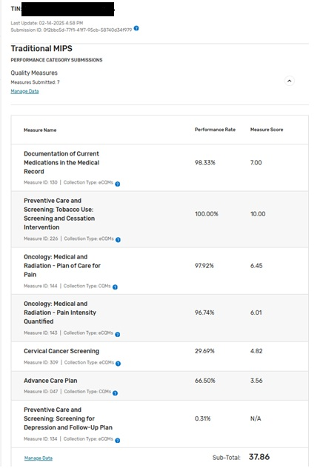

Measure 4: Single Patient ExporT
This measure assesses functionality used to export EHI for a single patient.
No Clinigence customer utilized this functionality during the Reporting Period.

Measure 5: Patient Population Export
This measure assesses the functionality used to export EHI for a patient population. We generated the required QRDA Cat III files, and made them available as Reports within the application.
Description | V5 CAT III Export Report ID
Cuyahoga Falls, OH | *5281  *5282  *5283
Bowling Green, KY | 5261
Bismarck, ND | 5266
Lawton, OK | 5262
Manhattan, KS | 5239
Roseburg, OR | 5247
Broomall, PA | *5279  *5280  *5284  *5285  *5286  *5287  *5288
Peoria, IL | 5263
Edina, MN | 5251
Dunmore, PA | *5267  *5268  *5269  *5270
Providence, RI | 5256

Somerset, NJ | *5257  *5258  *5259  *5260
Huntington, WV | 5250
Las Vegas, NV | 5289
Tacoma, WA | 5290

Key Milestones
The list of key milestones that were met during the Real World Testing process. Includes details on how and when the developer implemented measures and collected data. Key milestones should be relevant and directly related to outcomes discussed.

Key Milestone | Care Setting | Date/Timeframe
Confirm data extraction and import for all EPs who have purchased the MIPS reporting service | All | Jan. 1, 2025 – Mar. 31, 2025
Calculate measure scores for Groups and EPs selected to participate in the RWT | All | Jan. 1, 2025 – Mar. 31, 2025
Validate the measure scores | All | Jan. 1, 2025 – Mar. 31, 2025
Generate the QRDA Cat III files | All | Jan. 1, 2025 – Mar. 31, 2025
Upload QDRA CAT III files to QPP portal (eCQMs) and download submission reports | All | Jan. 1, 2025 – Mar. 31, 2025
Upload JSON files via QPP portal (CQMs) and download submission reports | All | Jan. 1, 2025 – Mar. 31, 2025
Create RWT results report | All | July 31, 2025
Submit RWT results report | All | January 2026

Attestation
This Real World Testing Results Report is complete with all required elements, including measures that address all certification criteria and care settings. All information in this report is up to date and fully addresses the Health IT Developer’s Real World Testing requirements.
Authorized Representative Name: Jason Roberts
Authorized Representative Email: jason.roberts@clinigence.com
Authorized Representative Signature: Jason Roberts
Date: January 21, 2026

